

**nCube-Thyme (Android)**

**Version: 1.0**

**Developer Guide v1.0**



Document Release Date: July 20, 2017

Copyright (c) 2017, OCEAN

All rights reserved.

Redistribution and use in source and binary forms, with or without modification, are permitted provided that the following conditions are met:

1. Redistributions of source code must retain the above copyright notice, this list of conditions and the following disclaimer.

2. Redistributions in binary form must reproduce the above copyright notice, this list of conditions and the following disclaimer in the documentation and/or other materials provided with the distribution.

3. The name of the author may not be used to endorse or promote products derived from this software without specific prior written permission.

THIS SOFTWARE IS PROVIDED BY THE AUTHOR ``AS IS'' AND ANY EXPRESS OR IMPLIED WARRANTIES, INCLUDING, BUT NOT LIMITED TO, THE IMPLIED WARRANTIES OF MERCHANTABILITY AND FITNESS FOR A PARTICULAR PURPOSE ARE DISCLAIMED. IN NO EVENT SHALL THE AUTHOR BE LIABLE FOR ANY DIRECT, INDIRECT, INCIDENTAL, SPECIAL, EXEMPLARY, OR CONSEQUENTIAL DAMAGES (INCLUDING, BUT NOT LIMITED TO, PROCUREMENT OF SUBSTITUTE GOODS OR SERVICES; LOSS OF USE, DATA, OR PROFITS; OR BUSINESS INTERRUPTION) HOWEVER CAUSED AND ON ANY THEORY OF LIABILITY, WHETHER IN CONTRACT, STRICT LIABILITY, OR TORT (INCLUDING NEGLIGENCE OR OTHERWISE) ARISING IN ANY WAY OUT OF THE USE OF THIS SOFTWARE, EVEN IF ADVISED OF THE POSSIBILITY OF SUCH DAMAGE.

**nCube: Thyme for Android**

nCube: Thyme for Android is developed based on oneM2M AE for Android Application. It supports MQTT, HTTP, CoAP communication protocols.

nCube: Thyme for Android can be developed with the Internet connection and Android OS development environment. This document is based on Android Studio virtual machine.

The process of developing nCube: Thyme for Android Application that uploads various information in everyday life to Mobius IoT Platform will be explained. This document explains how to run nCube: Thyme for Android Application using virtual machine and how to query resource structures created by nCube: Thyme for Android Application.

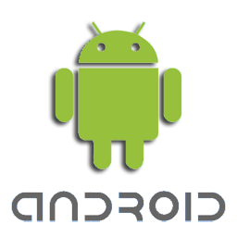

Based on this document, it is possible to create nCube: Thyme for Android Application that uses various data from IoT platform and controls long-distance IoT Devices.

Contents

1. Environment Setting 5

1.1. Java Developer’s Kit and git Installation 5

1.2. Android Studio Installation 6

1.3. Open nCube: Thyme for Android from Android Studio 7

1.4. nCube: Thyme for Android Setting 8

2. nCube: Thyme for Android Execution Exercise 9

Appendix A 19

1. Environment Setting

In chapter 1, hardware specifications for the development of nCube-Thyme for Android will be introduced. JDK and git installation, Android Studio installation, Android Studio environmental setting, nCube: Thyme for Android will be explained.

* 1. Java Developer’s Kit and git Installation

<http://www.oracle.com/technetwork/java/javase/downloads/index.html>

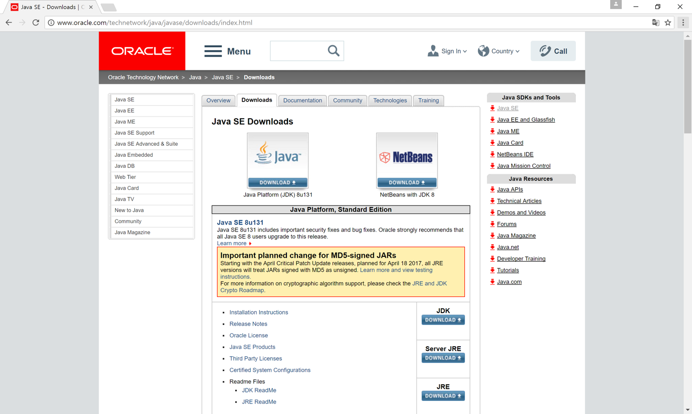

Download and install Java SE JDK from ORACLE webpage from URL above.

<https://git-scm.com>

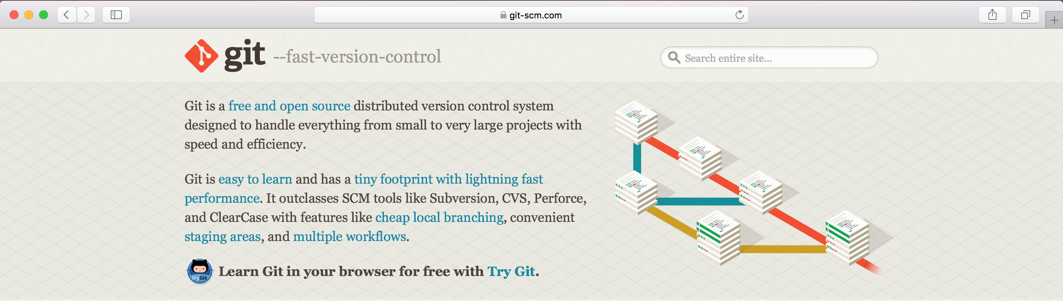  
Download and install git from the URL above.

* 1. Android Studio Installation

<https://developer.android.com/studio/index.html>

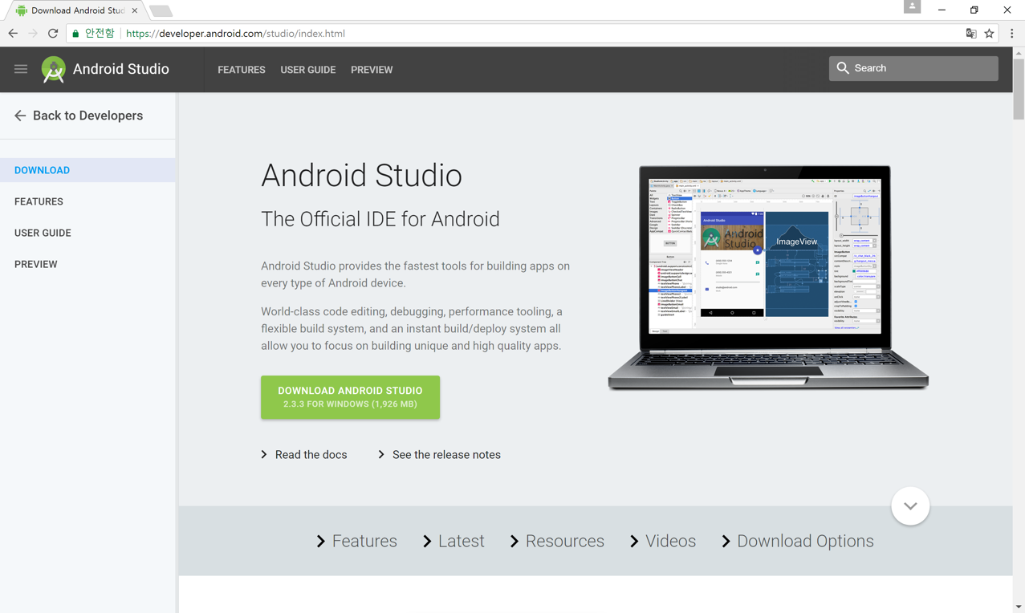

Download and install Android Studio from the URL above.

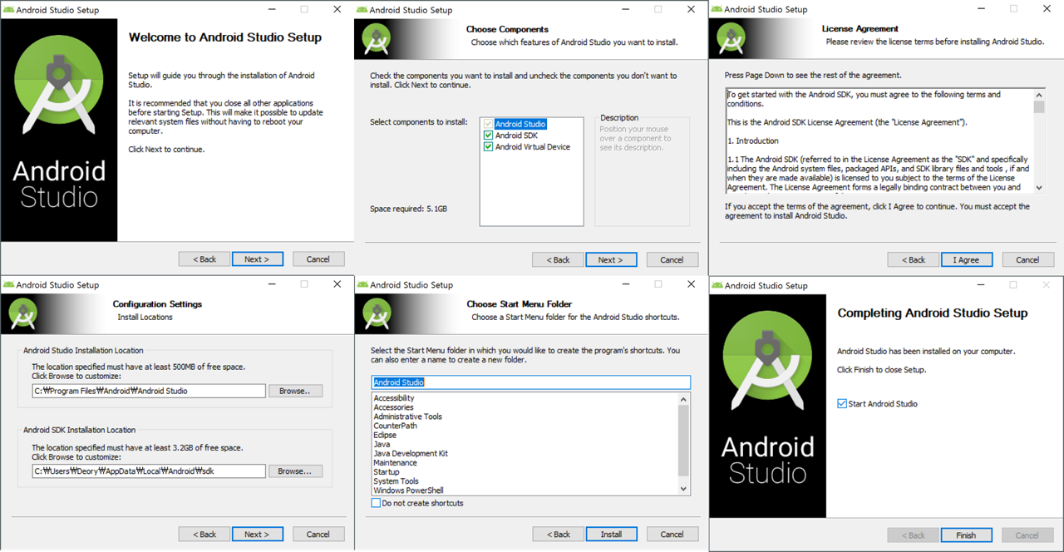

Execute Android Studio after installation.

* 1. Open nCube: Thyme for Android from Android Studio

<https://github.com/IoTKETI/nCube-Thyme-Arduino.git>

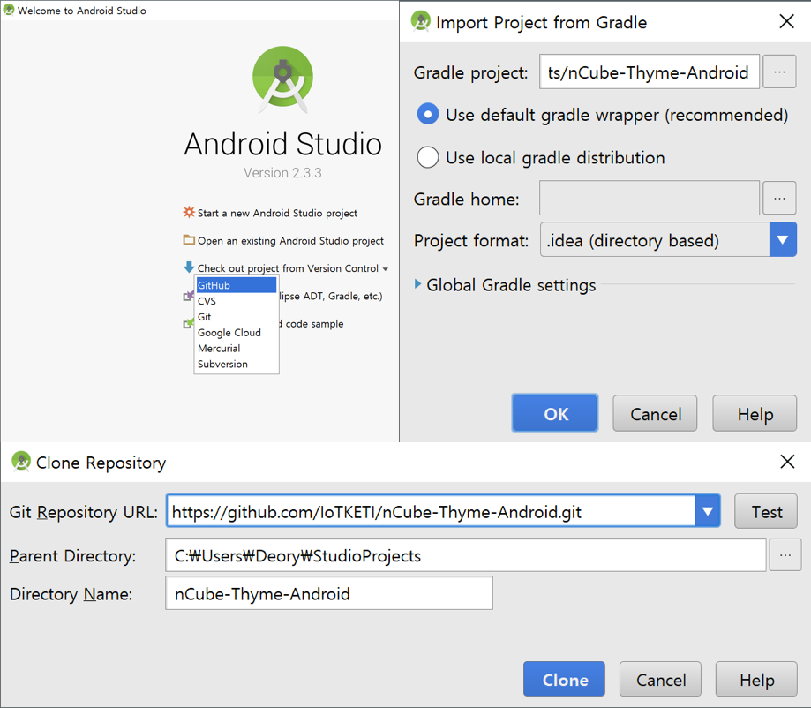

Execute nCube: Thyme for Android from Android Studio and input <https://github.com/IoTKETI/nCube-Thyme-Android.git> in Check out project from Version Control, Git Repository URL. Click clone button and import nCube: Thyme for Android project.

* 1. nCube: Thyme for Android Setting

{

    "useprotocol": "http",

    "cse": {

        "cbhost": "203.253.128.161",

        "cbport": "7579",

        "cbname": "Mobius",

        "cbcseid": "/Mobius",

        "mqttport": "1883"

    },

    "ae": {

        "aeid": "S",

        "appid": "0.2.481.1.1",

        "appname": "anCbueTest",

        "appport": "9727",

        "bodytype": "xml",

        "tasport": "7622"

    },

    "cnt": [

        {

            "parentpath": "/anCubeTest",

            "ctname": "sensorTest"

        },

        {

            "parentpath": "/anCubeTest",

            "ctname": "actuatorTest"

        }

    ],

    "sub": [

        {

            "parentpath": "/anCubeTest/actuatorTest",

            "subname": "sub-ctrl",

            "nu": "mqtt://AUTOSET"

        }

    ]

}

The contents of conf.json file from nCube: Thyme for Android is as above.

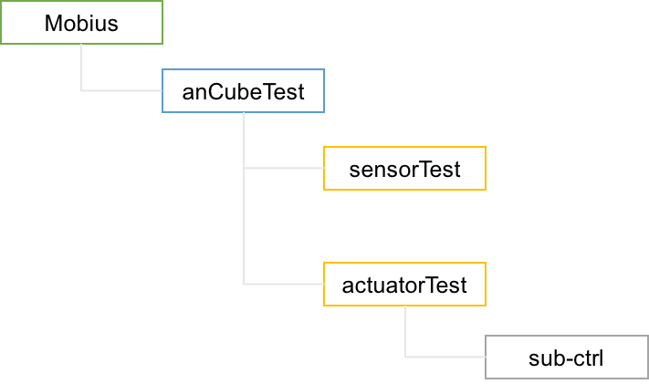

The resource structure of nCube: Thyme for Android can be presented is as above.

1. nCube: Thyme for Android Execution Exercise

In chapter 2, running nCube: Thyme for Android and querying resource created by nCube: Thyme for Android using Mobius Resource Monitor will be explained in detail.

Build and execute imported nCube: Thyme for Android application from GitHub.

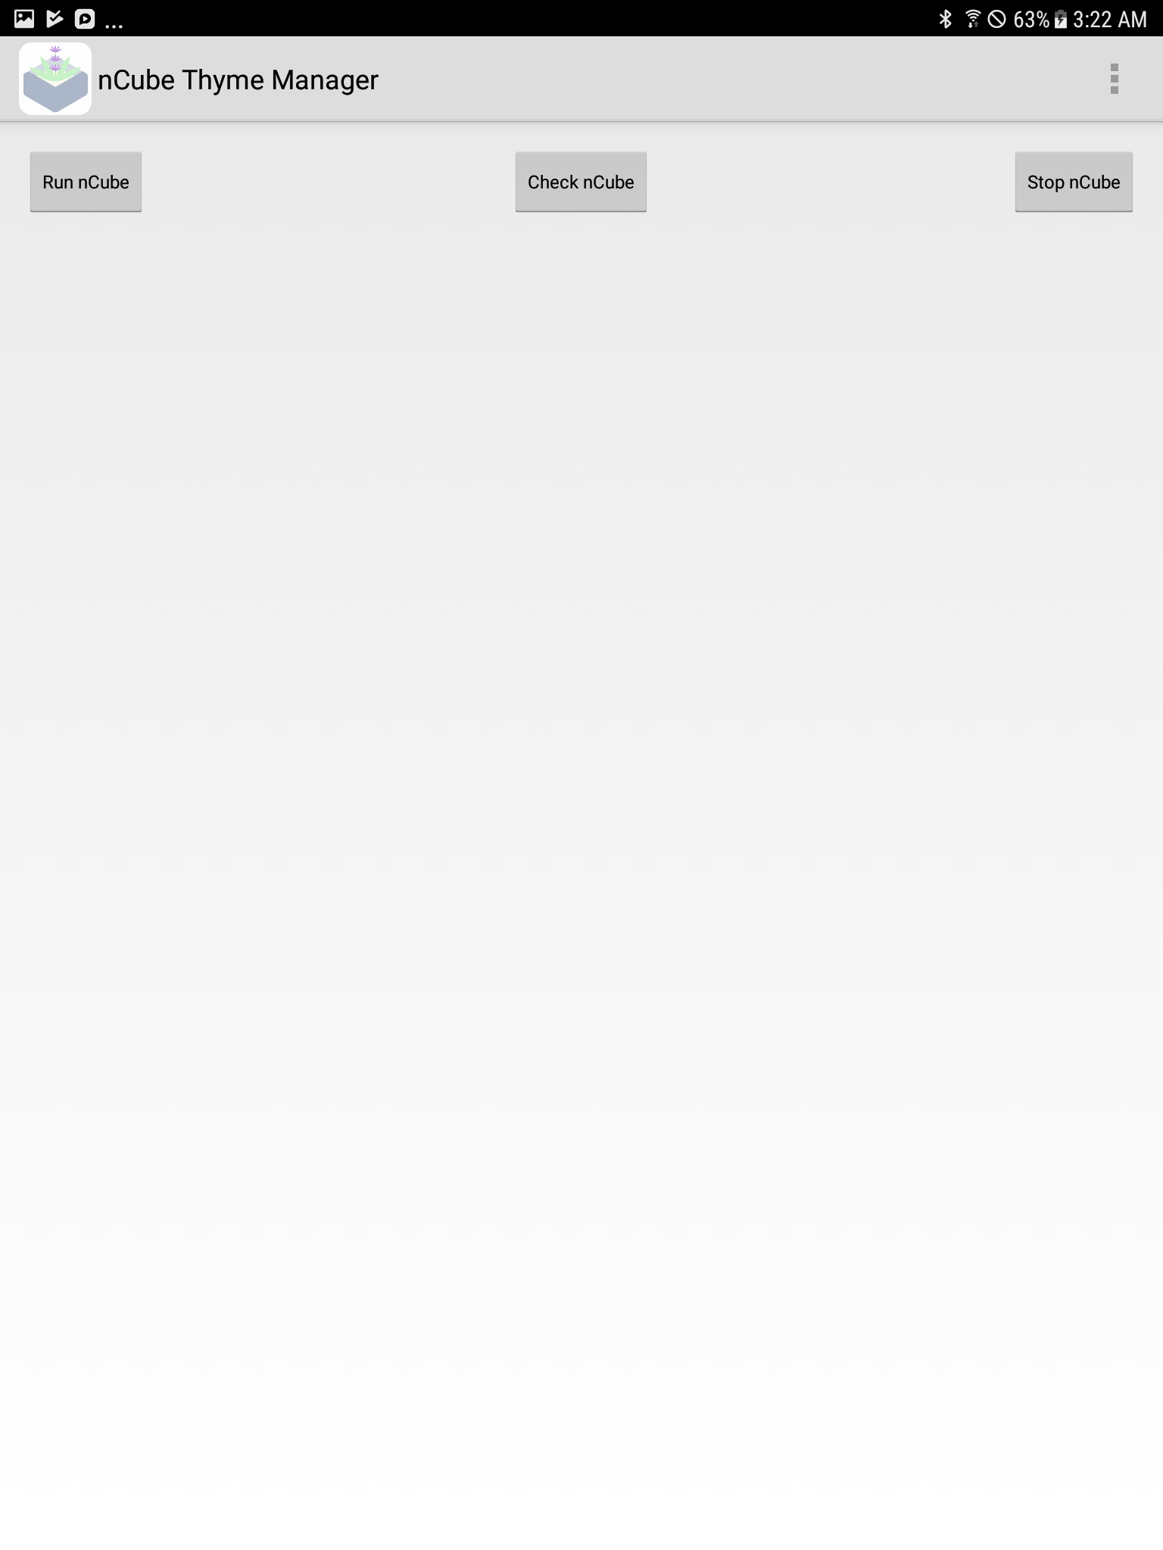

The figure above shows the start page of the application.

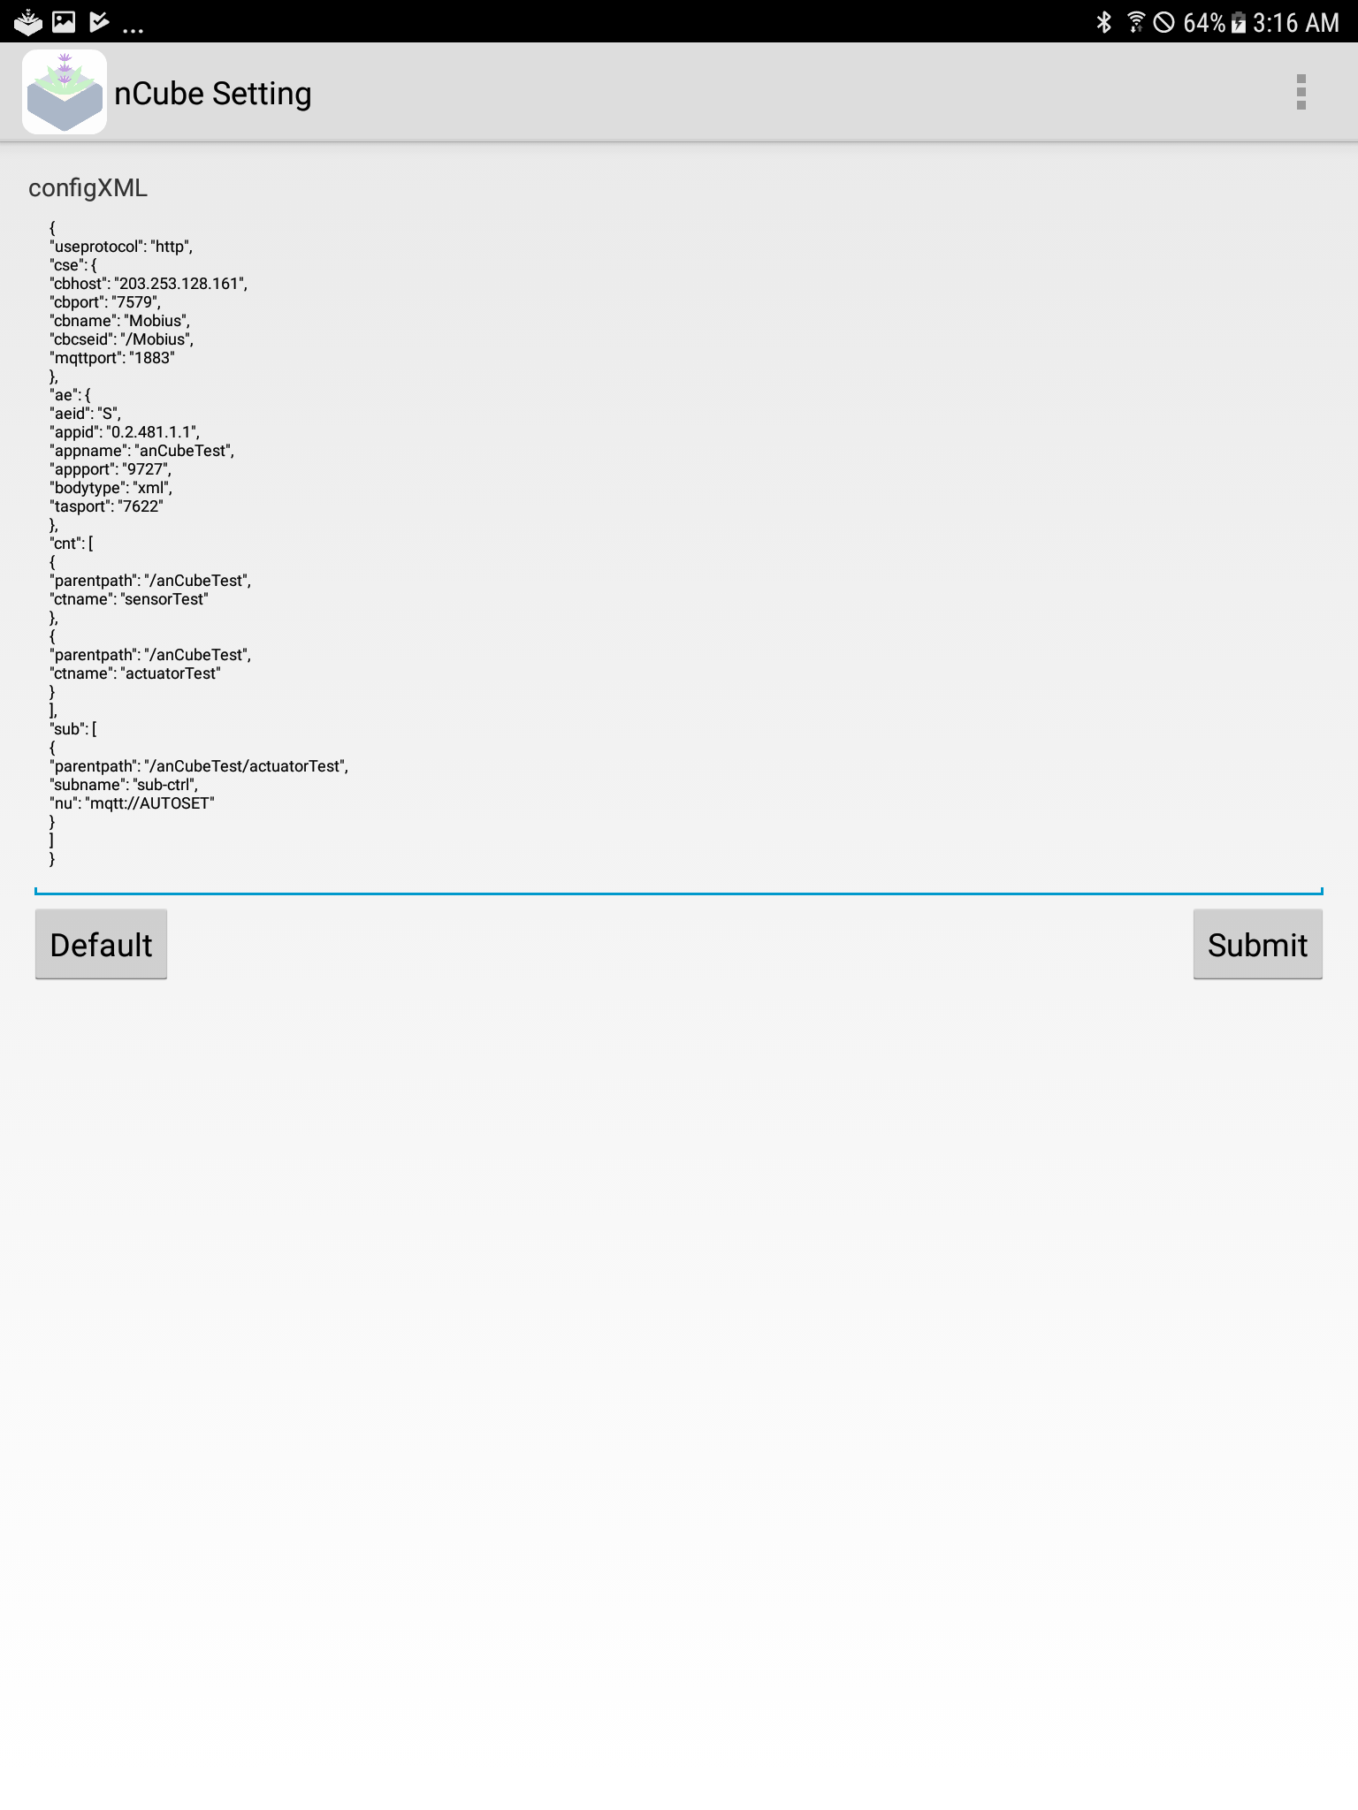

From the setting menu, click Default button and load resource setting. Then click Submit button.

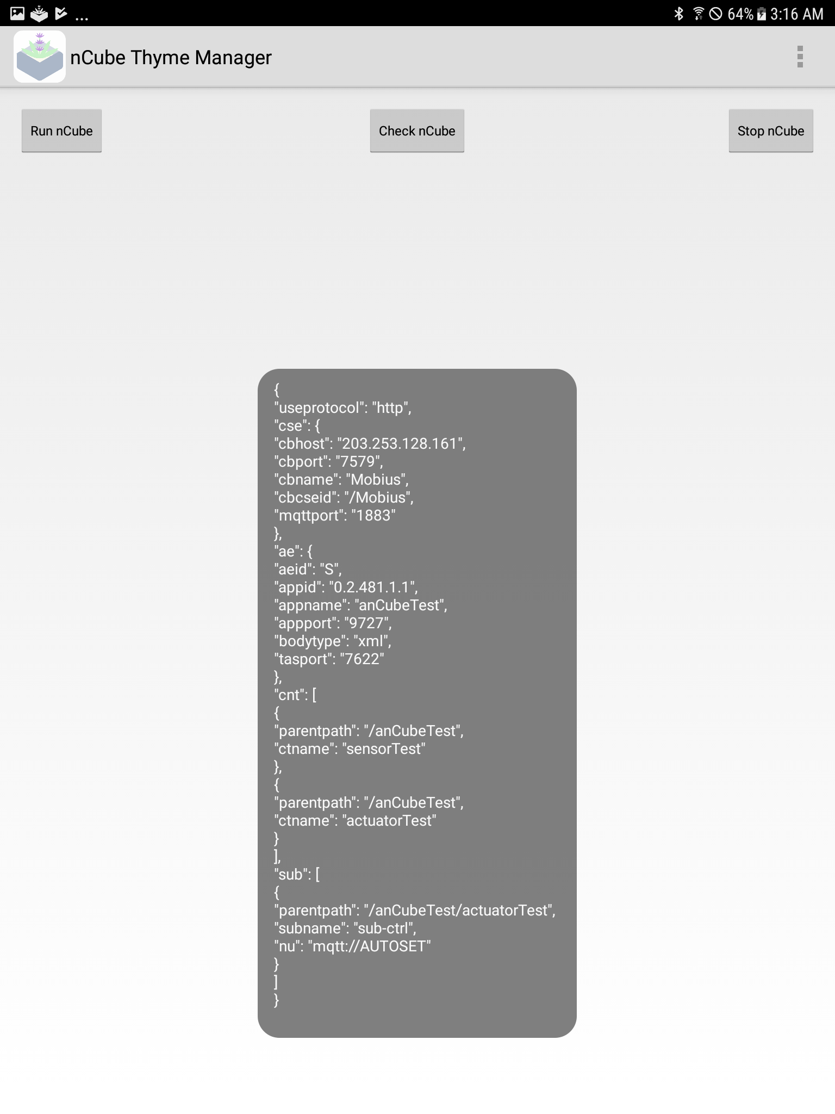

The above figure shows the toast of established resource structure.



From the main page of the application, click Run nCube button.

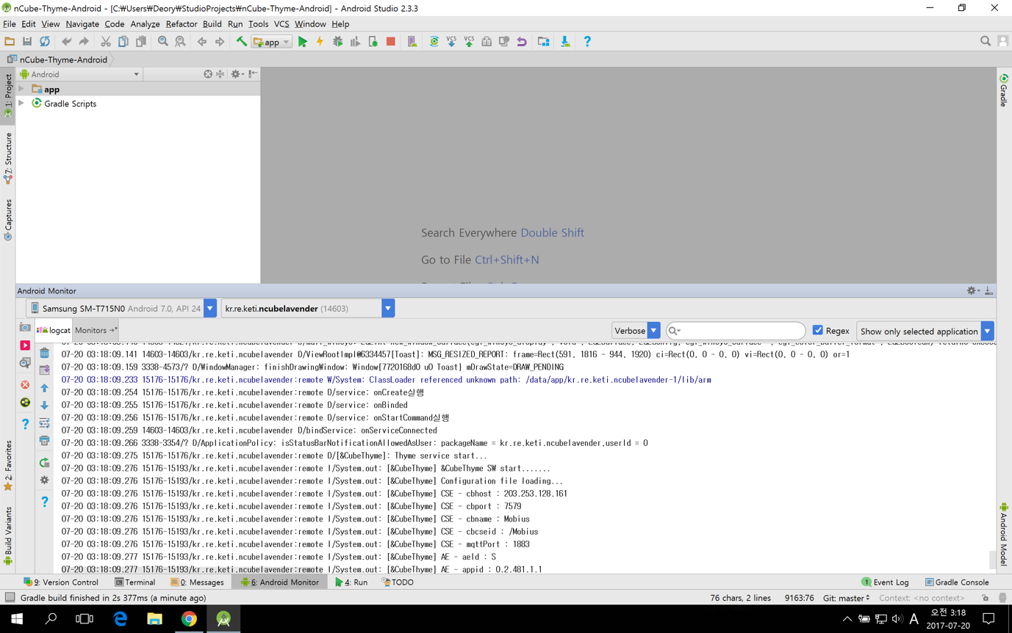

Confirm the appearance of the onServiceConnected log from the Android Monitor in Arduino Studio.

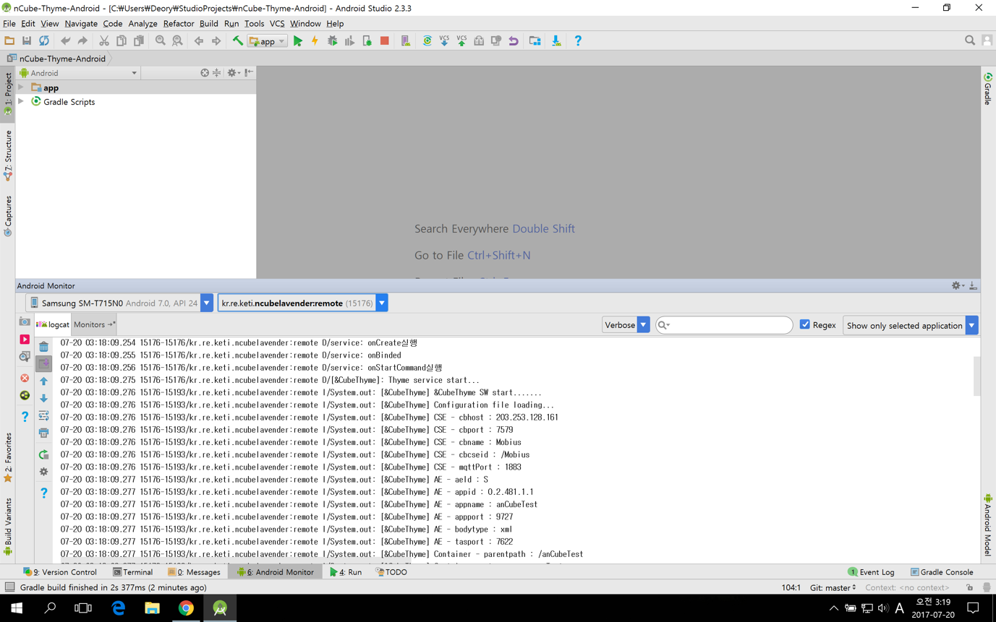

Select nCubelavender:remote process from Debuggable Processes, then the creation action logs of ae, cnt, sub from nCube:Thyme for Android will be shown.

<http://203.253.128.161:7575/>

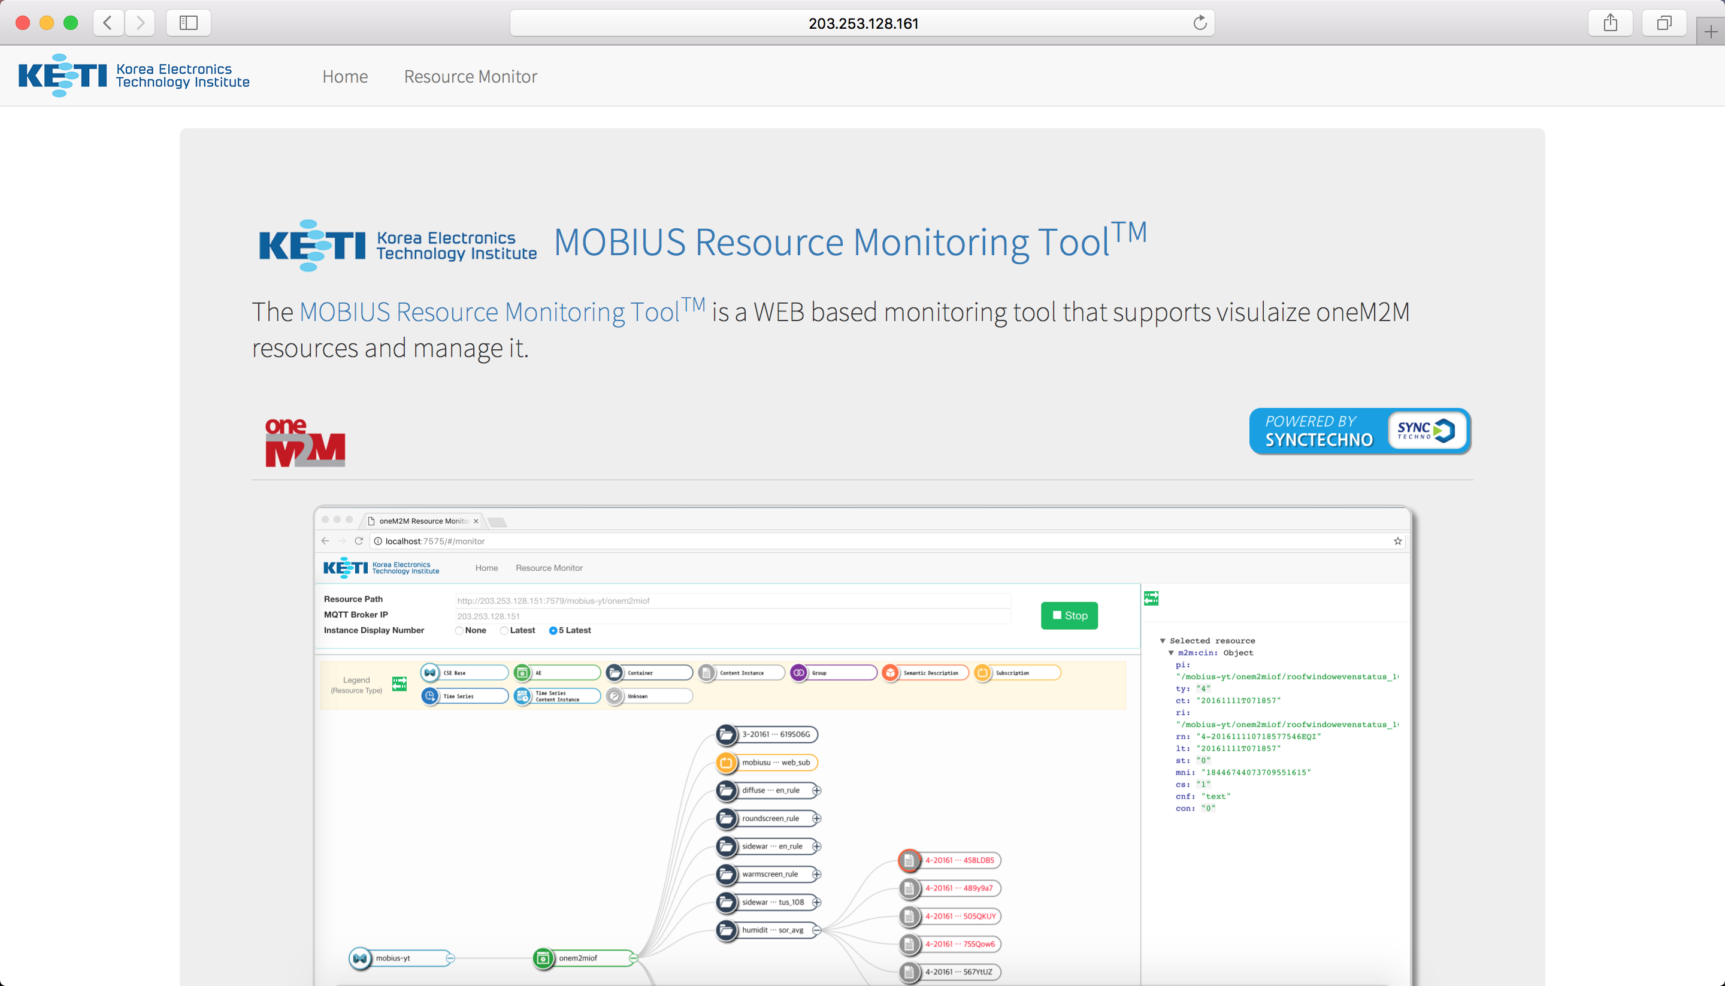

From the URL above, go to Mobius Resource Monitor. Click Resource Monitor tab to use Resource Monitor function.

<http://203.253.128.161:7579/Mobius/anCubeTest>

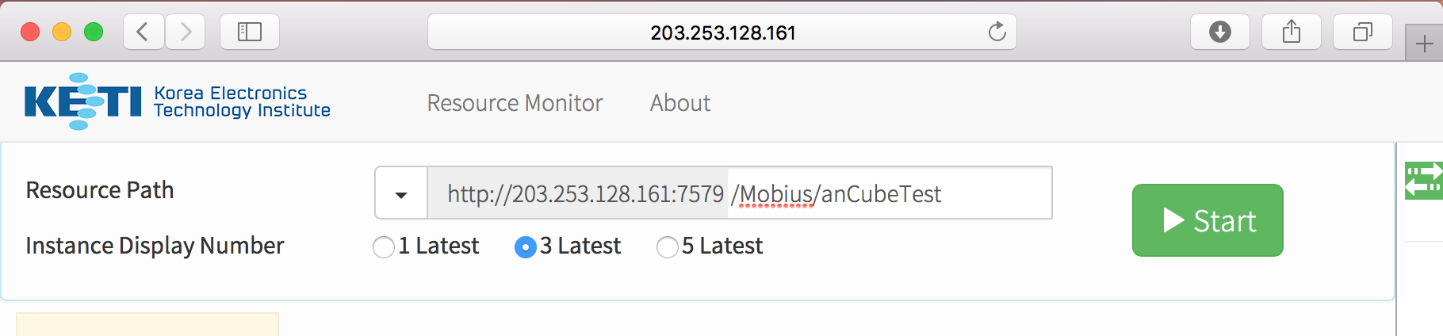

Input the address above in Resource Path and click Start button. nCube: Thyme for Android application created Resource Tree will appear as below.

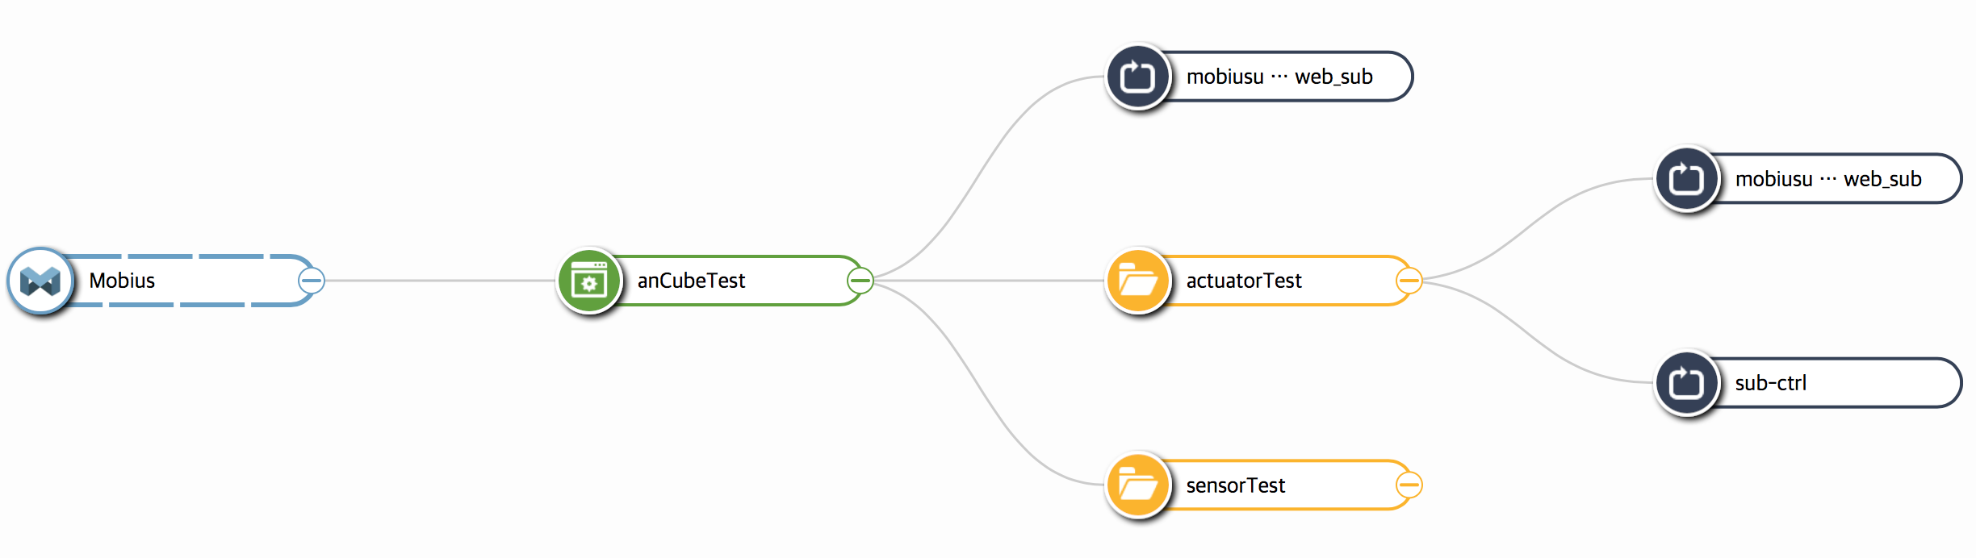

Resource structure is successfully queried as above.

**Appendix A**

**nCube: Thyme for Java Resource Query and Control Using Postman**

Browsing Co2 data updated with nCube: Thyme for Java and controlling LED are available with Postman Application in Google Chrome. Moreover, AE, CNT, CIN creation and querying with API is also available.

<https://chrome.google.com/webstore/detail/postman/fhbjgbiflinjbdggehcddcbncdddomop?utm_source=chrome-ntp-icon>

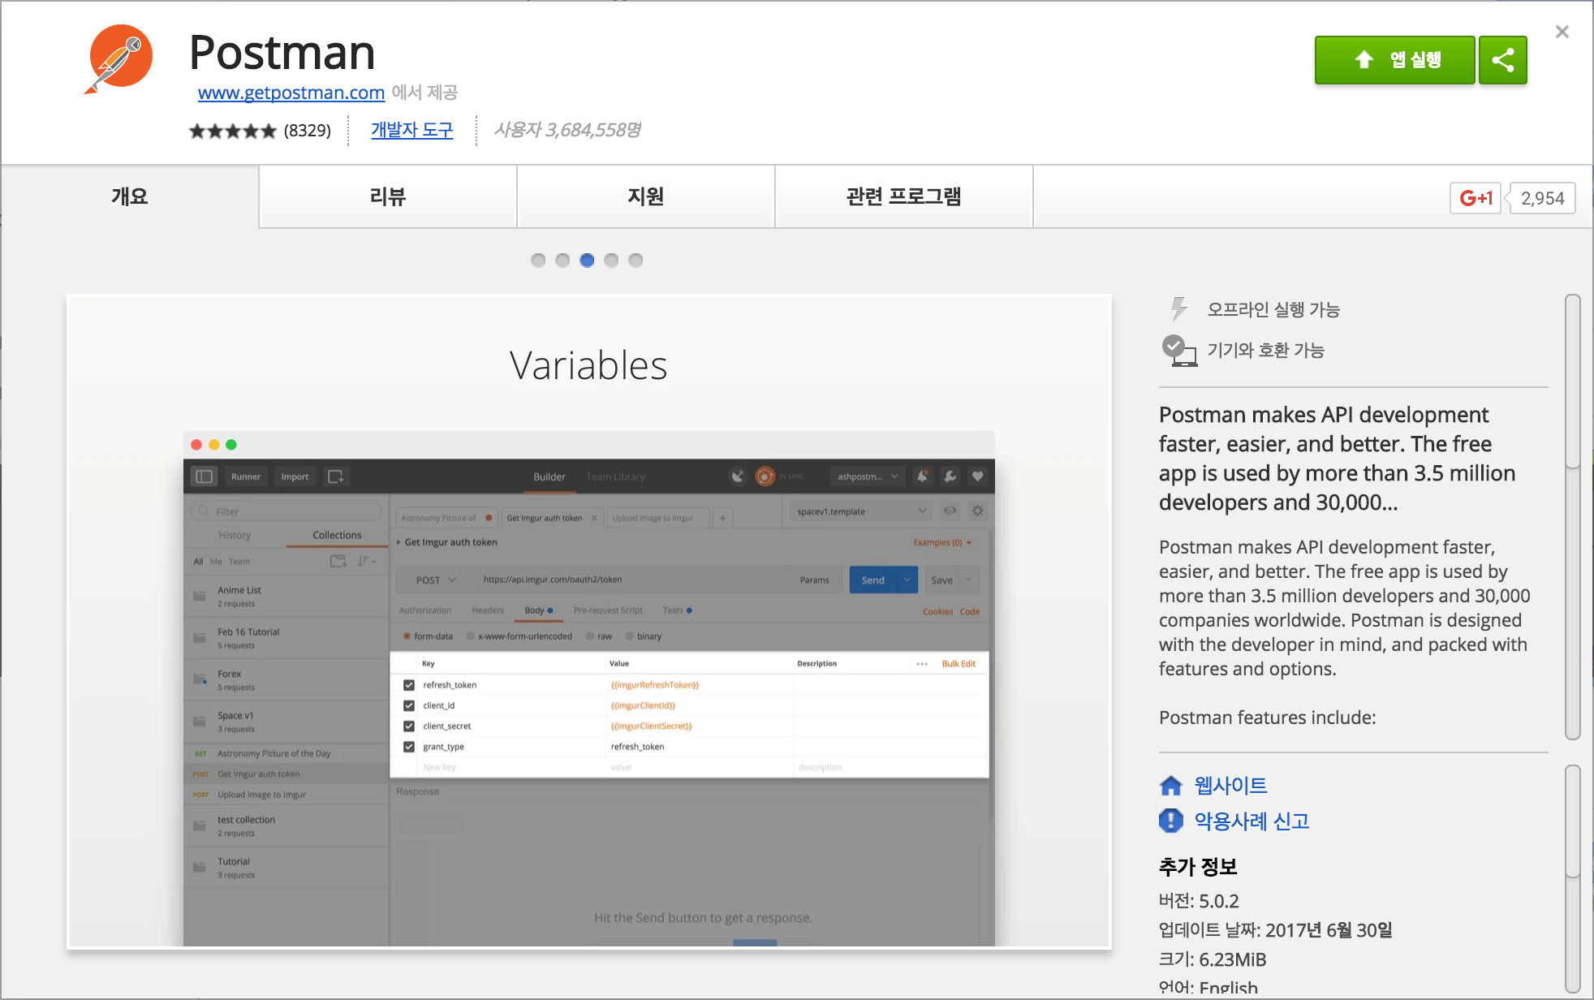

Download Postman Application in Google Chrome from the URL link above, and execute.

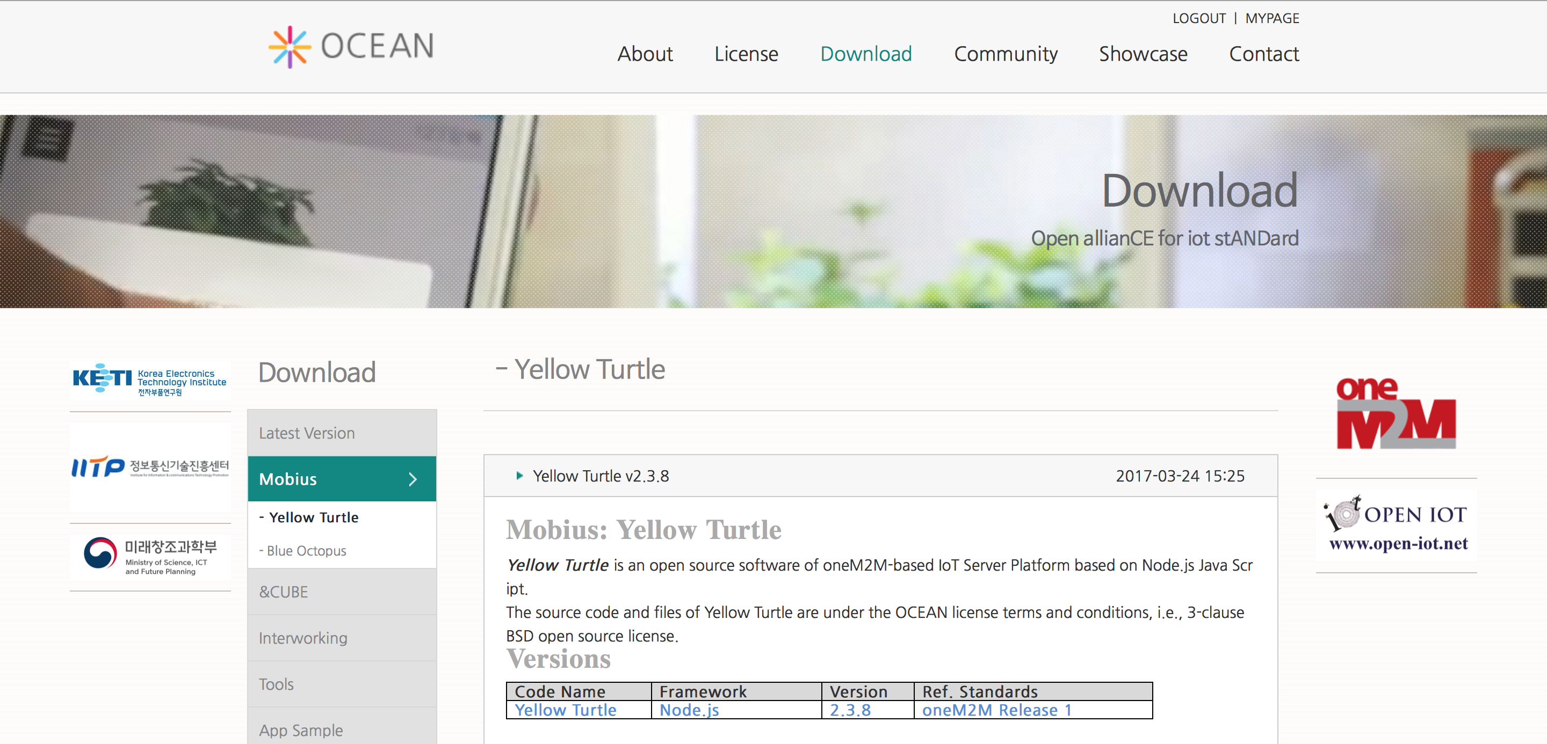



Go to the ocean official website (<http://www.iotocean.org>), Download>Mobius Yellow Turtle>POSTMAN Environment Scrip and click mobius-yt-7579.postman_environment.json and download Postman API collection.

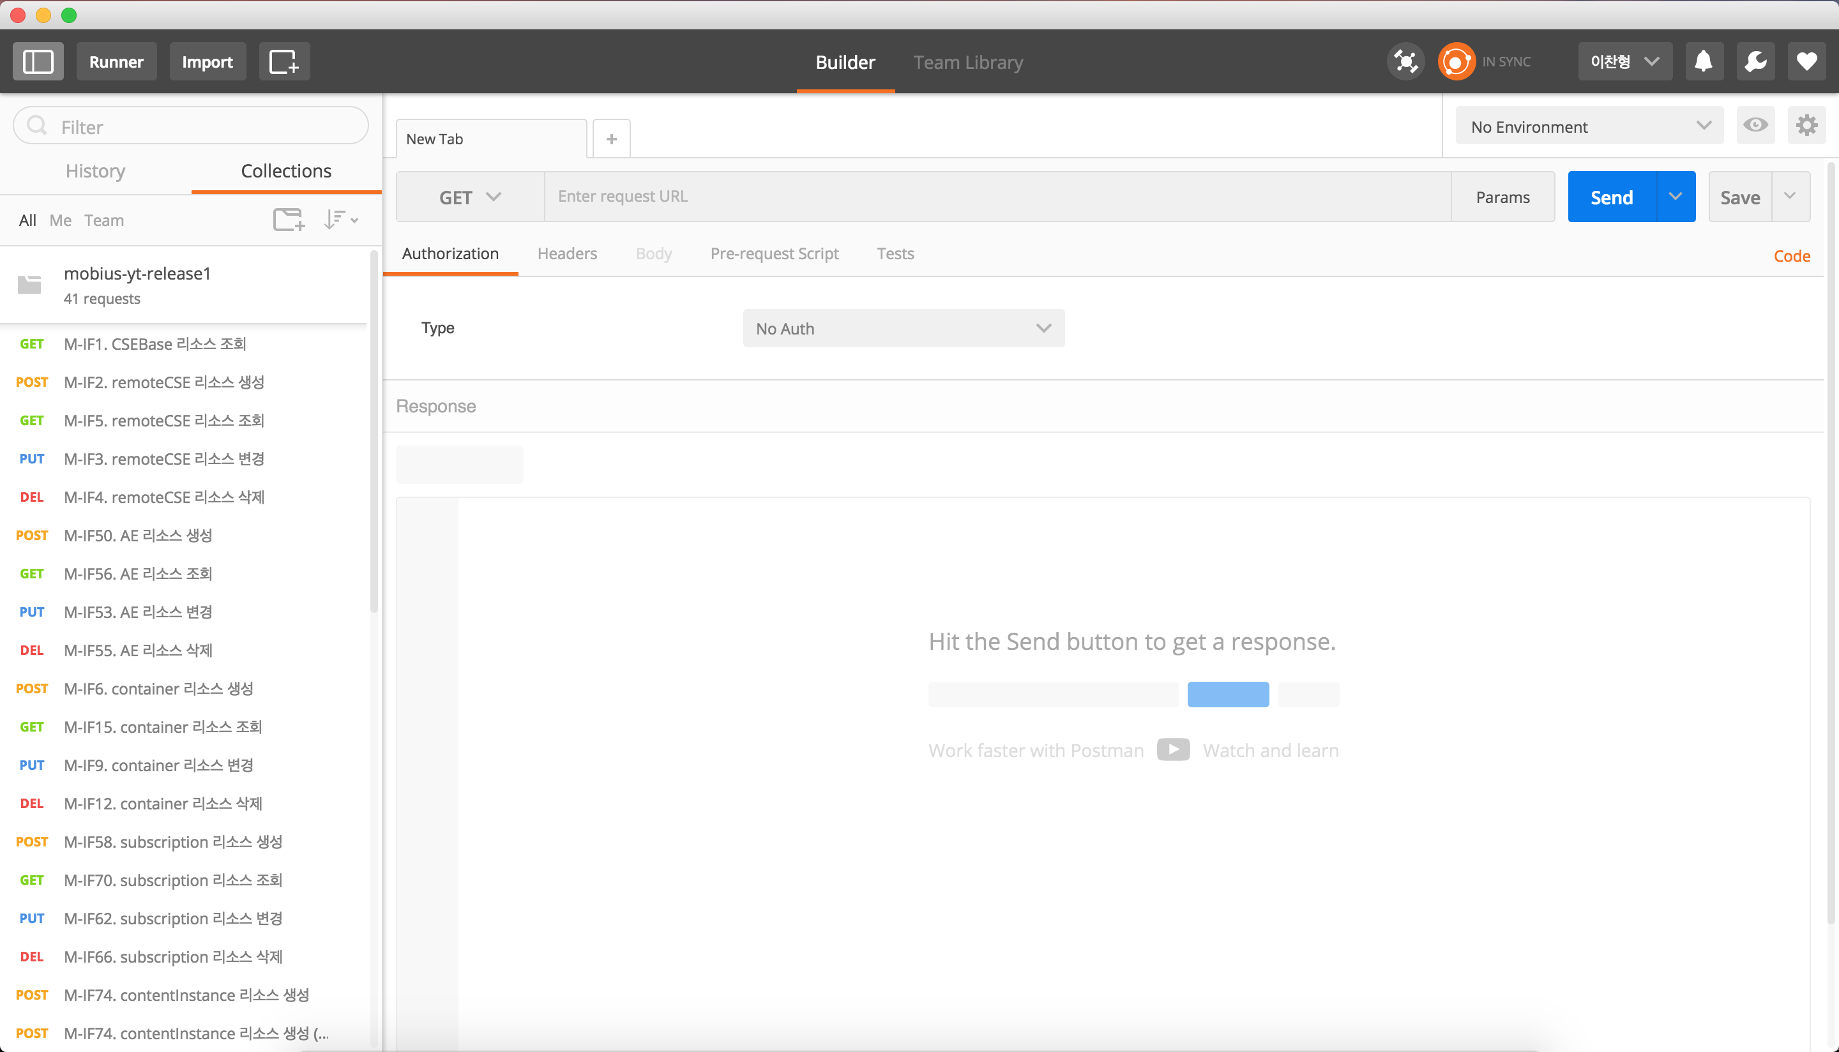

Open API collection in Postman by *import 🡪 import file 🡪 choose files*, then APIs are added under *Collections* list on the left. Resource query and creation is available using added APIs.